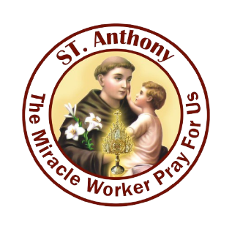
ARCHDIOCESE OF BANGALORE
St.Anthony’s Church
Munnekolala, Marathahalli, Bangalore-560037

Husband Name: ……………………………………………………………………….DOB:………/………../..................................
Wife Name: ……………………………………….............................................DOB: ………/…………/……………………………….
Date of Marriage: ….……/……………/……………… Place of Marriage: ……………………………......................................
Church of Marriage: ………………………………………………….. Place of Marriage: ………………………………………………….
Present Address: ………………………………………………………………………………………………………………………………………….
……………………………………………………………………………………………………………………………………………...........................
Email Id: ………………………………………………………………………………………………Phone no: …………..............................
Previous Parish name & Address: .....................................................................................................................
………………………………………………………………………………………………………………………………………………………………………
Occupation: Husband: ……………………………………………….Wife: ..........................................................................
Mother Tongue: Husband: ………………………………………………..Wife: …………………………………………………………….
Place of Birth: Husband: …………………………………………………….Wife: ………………………………………………………………
Date of Baptism: Husband: …………/………………/…………. Wife: ……………………/…...…………………/…………………….
Total number of children studying in Catholic / Christian Institutions: Boys ……………... Girls …………………….

S.No | Details of Family Members other than Husband & Wife (Nuclear Family) relationship | Relationship | Date of Birth | Date of Baptism | Occupation/  Studying

Note:
*For the FAMILY RECORD, the required document:
- Copy of Marriage Certificate
- Copy of your Children Baptism Certificates
- Previous Parish’s Parish Priest letter

Date……/……………/.......… Signature……………………………………...

